Name ______________________ Document Analysis Notes

Period _____ Date ____________ Forensics

1. Document Analysis ______________________________________________
   1. Definition: _________________________________________________

__________________________________________________________

* 1. Experts______________________________________________________________________________________________________________

1. Questioned Document
   1. Definition: _________________________________________________

__________________________________________________________

* + 1. Examples: _____________________________________________

______________________________________________________

1. Document Expert
   1. Definition: _________________________________________________ __________________________________________________________
   2. Graphology ________________________________________________ __________________________________________________________
2. History of Handwriting Analysis:
   1. __________________________________________________________
   2. An Exemplar is a ____________________________________________
      1. Items that could be used as exemplars: _____________________ ______________________________________________________
   3. 1930’s ____________________________________________________ __________________________________________________________
   4. 1999 _____________________________________________________ __________________________________________________________

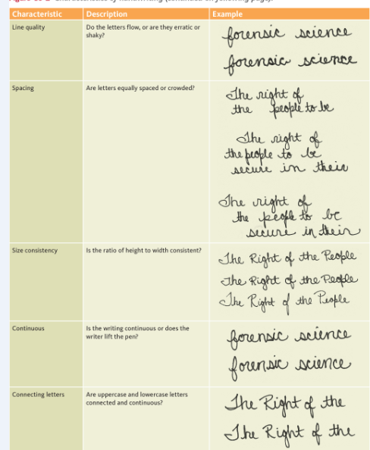

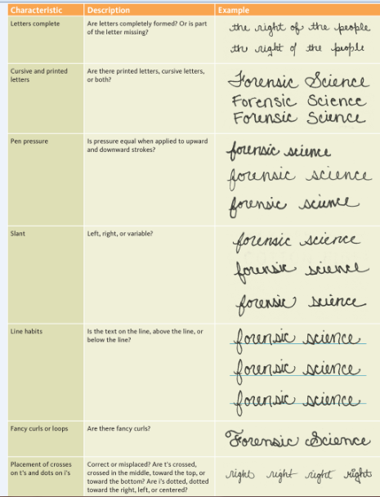

1. Graphology – ___________________________________________________ _______________________________________________________________
   1. Handwriting is a _____________________________________________
   2. Why people would like to know about graphology
      1. ________________________________________________
      2. ________________________________________________
      3. ________________________________________________
      4. ________________________________________________
      5. _________________________________________________ _________________________________________________
      6. Law enforcement in _________________________________
   3. What can influence handwriting:
      1. Mood, illness, drugs, amount of sleep, comfort of writer, type of _____________________________________________________
   4. What can be determined by looking at handwriting:
      1. ______________________________________________________
      2. ______________________________________________________
      3. ______________________________________________________
      4. ______________________________________________________
      5. ______________________________________________________
      6. ______________________________________________________
   5. What can’t be determined by looking at handwriting:
      1. ______________________________________________________
      2. ______________________________________________________
      3. ______________________________________________________
      4. ______________________________________________________
      5. ______________________________________________________
      6. ______________________________________________________
   6. Exemplars:
      1. ______________________________________________________
      2. ______________________________________________________
      3. ______________________________________________________
      4. ______________________________________________________
      5. ______________________________________________________
      6. ______________________________________________________
   7. ____________of Handwriting analysis is fairly correct.
   8. * The complete Idiot’s guide to Handwriting Analysis – Sheila Lowe
   9. Technology and Handwriting analysis:
      1. Infrared Stereoscope – ___________________________________ ______________________________________________________
      2. Biometric Signature Pads – (signing the computer pad with a ______________________________________________________

______________________________________________________

* + 1. Computerized Analysis
       1. Forensic Information System for Handwriting (FISH) is used _________________________________________________
       2. can in the exemplar and the computer can search for __________________________________________________

1. Forgery –_______________________________________________________ _______________________________________________________________
   1. Examples: __________________________________________________ __________________________________________________________
2. Fraudulence – ___________________________________________________
3. Preventing Check Forgery:
   1. __________________________________________________________
   2. Use a large font size because it requires more ink and is more difficult to alter
   3. Use high-resolution borders on the checks that are difficult to copy
   4. __________________________________________________________
   5. __________________________________________________________
   6. Use chemical-wash detection systems that change color when a check is altered.
4. Literary Forgery ­­­­­­­­­­­­­­­­­­­­­­­­­­­­­_________________________________________________ ______________________________________________________________
5. Counterfeiting
   1. Definition – ________________________________________________ __________________________________________________________
   2. Most commonly counterfeited: ________________________________

__________________________________________________________

* 1. __________________________________________________________
  2. __________________________________________________________ __________________________________________________________

1. Counterfeit Currency
   1. The secret service has updated currency to make it less possible to scan.
   2. Money i____________________________________________________
   3. Bills were redesigned
      1. $20 in _________________
      2. $50 in _________________
      3. $10 in _________________
      4. $5 in __________________
   4. Detecting counterfeit currency
      1. ______________________________________________________
      2. Counterfeit bills will turn bluish-black. Iodine has a chemical reaction to normal copy paper.
      3. ______________________________________________________
      4. ______________________________________________________
   5. Features found in real currency
      1. ______________________________________________________
      2. ______________________________________________________
      3. Serial number is evenly spaced and the same color as the treasury seal.
      4. Federal Seal has no sharp points but treasury seal has sharp, clear saw tooth points.
      5. ______________________________________________________
      6. ______________________________________________________
      7. When tilted, the number in the lower right-hand corner shifts color.

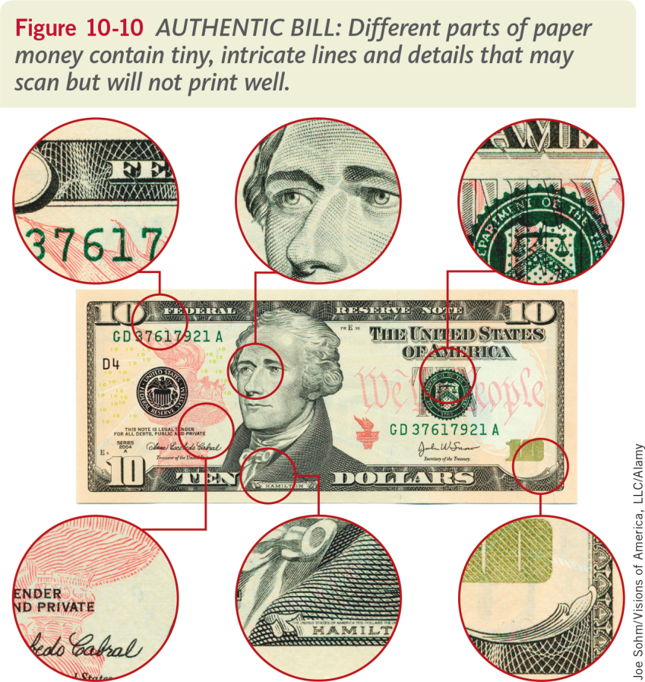

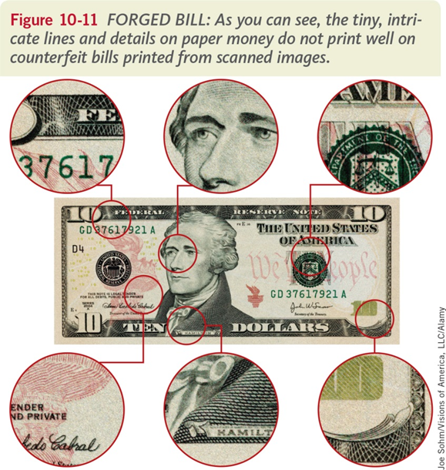

1. Chromatography
   1. Definition: ______________________________________________________ _______________________________________________________________
   2. ______________________________________________________________________________________________________________________________
   3. Chromatography can also be used to separate the colored pigments in plants _______________________________________________________________
   4. Examples of Chromatography
      * 1. Liquid Chromatography _______________________________________ __________________________________________________________
        2. Thin-Layer Chromatography ___________________________________ __________________________________________________________
        3. Gas Chromatography _________________________________________
        4. Paper Chromatography _______________________________________ __________________________________________________________
   5. Mixture - _______________________________________________________ _______________________________________________________________
      1. Examples:
         1. __________________________________________________________
         2. __________________________________________________________
         3. __________________________________________________________
         4. __________________________________________________________
   6. Compounds ____________________________________________________
      1. Examples:
         1. __________________________________________________________
         2. __________________________________________________________
   7. Solutions _______________________________________________________ _______________________________________________________________
      1. Solute: _____________________________________________________
      2. Solvent: ____________________________________________________
      3. Identify the solute and solvent in the table below

|  |  |  |
| --- | --- | --- |
| Solution | Solute | Solvent |
| Lemonade | Sugar and lemon juice |  |
| Soda Pop |  | Water |
| Ocean Water | Salts |  |